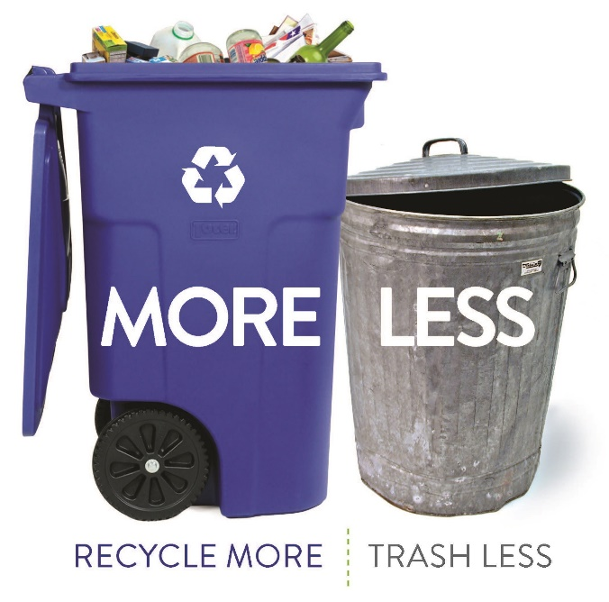
 | City o | Appendix E:  Phase 3: Trash Barrel and Curbside Collection Survey Results  Zero Waste Master Plan  City of Cambridge, MA  January 25, 2019

Appendix E: Trash Barrel and Curbside Collection Survey Results
Statement of Purpose
In Appendix C it was recommended that the City examine implementation of a standard curbside collection container, as an incentive to divert and to address other issues associated with trash collection (issues with tidiness of set-outs, rodents and health & safety of collection staff). In order to determine the appropriate capacity that would be provided to each household for trash collection (e.g. gallons of capacity in the standard container), a curbside survey was recommended for 2018. Given that organics collection was expanded to all buildings with 12+ units earlier in the year, this survey also provided an opportunity to observe organics set-outs and to look at recycling set-outs.
This report on the outcome of the trash barrel and collection survey results provided essential information to support the public engagement activities undertaken in December 2018 and was used to support the recommendations in the ZWMP.
This document is a supporting background document for the ZWMP, documenting the outcome of one component of Phase 3 of the ZWMP process. No further amendments will be made to this document based on review of the ZWMP.
In October 2018, a trash barrel, recycling cart, and green bin set-out survey was conducted. The survey was completed in accordance with the attached protocol. The following provides a brief text overview of the results of the survey.
A total of 294 addresses comprising 743 dwelling units were covered in the curbside audit, ranging from 55 to 61 addresses each day from Monday, October 22 to Friday, October 26, 2018.
- Trash Audit Survey Summary
The City is considering provision of a standard container based on 32 to 48 gallons per unit would allow the City to provide different containers in multiples of 16 (e.g. 48, 64, and 96 gallons) and is an equitable division of capacity on a per unit basis. Thirty-two and 48 gallons works out to approximately three to four bags of trash per week which appears to be ample capacity based on the feedback from the organics pilot participants.
The following presents an overview of the data collected regarding the curbside trash set-outs during the week of the audit:
- Average size of trash barrels used = 42.4 gallons
- Average weight of trash per barrel = 20.3 lbs
- Average weight of trash per dwelling unit was 12.3 lbs/unit. Ranged from 9.3 lbs/unit (Monday area) to 18.3 lbs/unit (Thursday area).
- Thirty-four additional trash bags were set out on the curb outside of barrels. 11.6% of the total addresses set out bags on the curb. This ranged from only 5% in the Friday area, to 30% in the Thursday area.
- Average percent of trash barrels that were full or overfull was 43.6%. Ranged from 31.3% in the Monday area to 56 % in the Thursday area.
- The percentage of units that set out less than 32 gallons of trash ranged from 85% in the Monday and Wednesday areas, 83% in the Tuesday area, 79% in the Friday area and 54% in the Thursday area. The overall average number of units that set out less than 32 gallons of trash was 77%.
Outside of the averages, it is important to examine the range of behaviors observed in the trash set-outs, as they indicate both the positive end of the range from households that set out very little trash and which would have less difficulty if they were provided with less capacity for trash set-outs, to the upper end of the range which could indicate households that may have significant difficulty adapting to a standard container program.
Figures that indicate the range of behaviors observed in the trash audit are included in Attachment 2.

- Recycling Summary:
The curbside collection survey allowed for the City to observe the participation by residents in the curbside recycling program, and to see if the recycling capacity provided to households is sufficient to meet their needs.
The following presents an overview of the data collected regarding the curbside recycling set-outs during the week of the audit:
- Average set out rate (percent of addresses where recycling was set out) = 89.5%. Ranged from 74.6 % in the Wednesday area to 100% in the Monday area.
- 73% of the set outs were 65 gallon carts, 21% were 95 gallon carts, and 6% were other types of containers.
- 49% of the recycling containers were full or overfull. Ranged from 35% of the containers being full or overfull in the Tuesday area, to 61% being full or overfull in the Monday area.
- On average the recycling capacity used per unit = 36 gallons. Ranged from 26 gallons per unit in the Wednesday area to 42.7 gallons per unit in the Tuesday area.
Given that in the order of half of the recycling containers were full or overfull, and given the potential transition to a standard trash container, which will encourage more recycling, it appears that the City should consider providing additional recycling capacity as part of the ZWMP implementation.

- Green Bin Organics Summary:
The curbside collection survey allowed for the City to observe the participation by residents in the green bin organics program, and to see if the organics collection capacity provided to households is sufficient to meet their needs.
The following presents an overview of the data collected regarding the curbside green bin set-outs during the week of the audit:
- Overall set out rate (percent of addresses where a green bin was set out) = 50%. This ranged from 71% in the Monday area (which has had organics collection for a few years) to 45% in the Thursday area.
- On average the percent of green bins that were less than ½ full was 70.7%. This ranged from 64% in the Monday area to 80% in the Friday area.
There is room for improvement in the set-out rates for the green bin program. It is necessary to continue to promote and educate residents on the value of using the program along with incentivizing diversion (and dis-incenting trash disposal) through limiting trash quantities at the curb, in order to capture more of the organics stream for diversion. There appears to be sufficient capacity in the existing green bins, to sustain improvements in program performance.
- Bulky and Yard Waste Summary
The following presents an overview of the data collected regarding the curbside bulky and yard waste set-outs during the week of the audit:
Bulky Waste:
- There were 21 bulky material set-outs, with under 3% of addresses setting out bulky materials.
- 33 items were set out for collection.
- Items included: furniture, large boxes, pillows, glasses, electronics
Yard Waste:
- 39 containers of yard waste were set out. Almost half in the Monday area, ¼ in the Thursday area.
- Both yard waste bins and bags were set out.

- Overall Findings
The overall findings brought into development of the ZWMP recommendations included the following:
- Households in the Monday area (the area that has had organics collection for a longer period of time) set out less trash at the curb than other areas that were audited and had higher set out rates for recycling and green bin organics collection.
- In regards to the standard container size required for trash, the capacity needed per household based on current behavior would be approximately 32-48 gallons per dwelling unit for weekly trash collection.
- It appears that households could use additional recycling capacity.
- Significant capacity remains in the organics bins to facilitate higher organics diversion rates.

Attachments:
Attachment 1 – Cambridge Trash Barrel Auditing Protocol Final
Attachment 2 – Cambridge Trash Audit, Compiled Data Final (provided as an electronic file to the City)

Attachment 1:
Trash Barrel Survey Protocol

To gain further insight into the disposal practices of Cambridge residents, a survey of curbside setouts will be undertaken. The survey will consist of documenting the number and type of waste containers and bulky trash placed out for collection, documenting the fullness of each type of container, a visual survey of the types of materials placed in the containers and the weight of the trash barrels.
This survey will take place over five consecutive days, tentatively scheduled to commence on October 22, 2018. Two teams will be deployed with two people per team. The goal is to observe 30 set outs per day per team for a total of 300 observations.
In collaboration with the City, auditing zones will be identified within certain collection zones in the City. Each team will be given a set of individual zone maps identifying the boundaries of the zones they are to target during the observation period.
It will be critical that the auditing teams be in the field before collection starts. The City will notify collection crews that the auditing staff will be on certain routes in order that material is not collected before the auditing staff have a chance to obtain the required data.
Survey Methodology
The auditing team will undergo health and safety training prior to the audit, as well as training on how to conduct the audit. Teams will be equipped with the following:
Equipment needed:
- PPE – gloves, steel-toed boots, safety vest, long sleeve shirt
- Camera
- Paper forms and clipboard
- Letter from City
- Backup batteries and/or charging device for camera
- Weigh Scales
The team will meet at the Cambridge DPW office located at 147 Hampshire St, Cambridge, MA 02139 from 6:00 to 6:15 a.m. A City staff member will be available to drive the team to the start of the route.
The team will proceed to the first observation point and record the property address on the provided forms.
The team will:
- Note the physical location of the container(s).
- Take a photograph of the entire setout.
- Observe the number and type of containers and the size of each and input on paper forms.
- Be on the lookout for the possible presence of guard dogs/animals/rodents that may be nearby, as well as materials that may be protruding from or piled around containers.
- Carefully approach the container(s) and look inside. If the containers are closed, carefully open lid (using gloves) and observe the approximate amount of material in each container (i.e. percent full), and the top two major visible components. If visible, also note if there is material in the container that does not belong there (i.e. trash in the recyclables container or recyclables in the waste container). Do not attempt to reach inside the container(s) to see what is underneath the top layer or within bags. If the containers are locked, move on to the next location. Do not open any bags. When opening and closing containers, watch for pinch points and insects and/or vermin.
- Take one photograph of the outside and one photograph of the contents of each container observed. Auditors will link the photographs and setouts for future reference.
- Each trash container will be placed onto the scale so that the weight may be recorded.
- All containers, and doors/lids will be returned to the original position.
Team members will record the following on the forms:
- address
- number and type of waste containers set out (trash, food scraps, recycling)
- weight of each trash container set out
- fullness of each container set out (1/4, ½, ¾, full, overflowing)
- visual survey of types of materials in each container (top two major visible components)
- number and type of bulk items set out for collection
- number of housing units contributing to setout, if obvious (e.g. single family home, duplex, triplex, etc.)
If the property owner or occupant asks questions, show them the letter from the City and be prepared to move on to the next location. Always be courteous, explaining the purpose of the study.
On the first day, find a street where trash containers have already been collected and weigh a variety of empty containers so a tare weight may be recorded. The container types will have to be matched to the setout so tare weights may be subtracted.
Should material already be collected, have the City driver radio to DPW to select another route.
Stay hydrated, even though the weather will be cooling off, it may still be warm and a lot of walking will be involved. Download data at the end of the day or beginning of the next day to prevent data loss.

